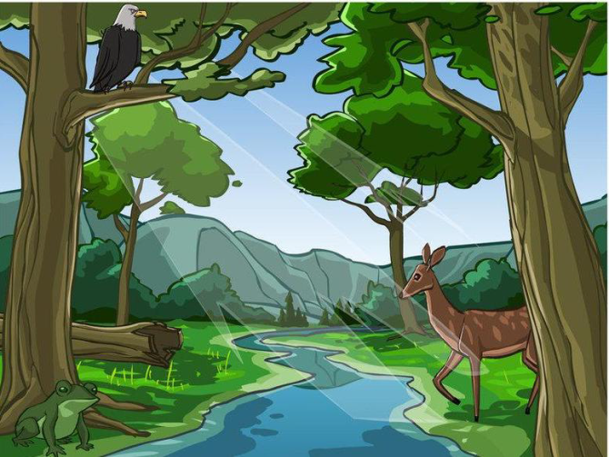
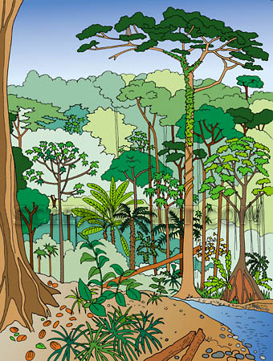

Why Are Plants Green? Or Not?
Plant Pigments: Chlorophyll

Most light sources give off visible light. Visible light is composed of seven colors: red, orange, yellow, green, blue, indigo, and violet. When visible light strikes an object your eyes see that object of a certain color. This is because the object absorbed all the colors of the light spectrum, except the color it reflects. If you see an object yellow, it is because the object absorbed all the colors, and reflected the yellow color. The yellow reflection is what hits your eye. Pigments, on the other hand, are substances that absorb light. Chlorophyll is a special green pigment; it is the main pigment in plants.
Sunlight is made up of visible light and has the seven colors. When sunlight strikes a leaf, the light is absorbed by chlorophyll. Chlorophyll absorbs red, orange, blue, indigo and violet light, and reflects yellow and green light. This is why we see the leaves green, chlorophyll reflected those two colors in great amounts.
This fact is illustrated in the color spectrum graph below. The bar graph shows the absorption rate of chlorophyll in a leaf. As you can see if you follow the line, green is the color with the smallest rate of absorption. The leaf is reflecting green light. There are leaves of different colors, that means that they absorb more green, and reflect the color that appears to your eye.

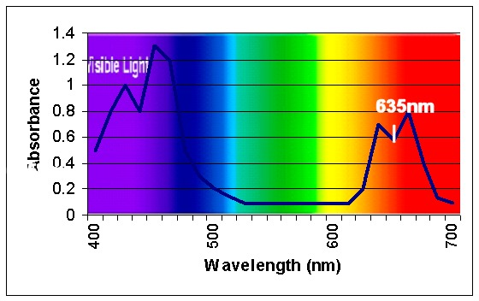

Source: Life Science. Concepts and Challenges, p. 47.

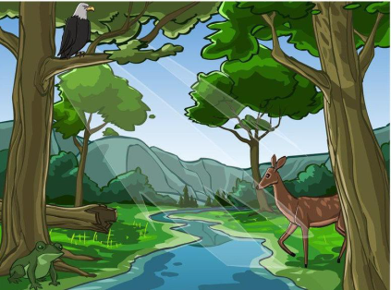
VISIT TO THE FOREST: TWO-COLUMN READING CHART
Barro Colorado Island: Virtual Tour
Wisconsin Forests: Activity Field Trip

Name: _______________________________________________________ Date: ___________________________

Reading Assignment
(Book, Section, Pages): __________________________________________ Teacher: ________________________

Heading/Subheading  Page Number: | Notes

Term  Page Number | Definition  (in your own words) | Illustration  (use colors)

VISIT TO THE FOREST: ILLUSTRATED DEFINITIONS
Barro Colorado Island: Virtual Tour
Wisconsin Forests: Activity Field Trip

Name: _______________________________________________________ Date: ___________________________

Reading Assignment
(Book, Section, Pages): __________________________________________ Teacher: ________________________

