How Panama Changed the World: Stories of Geography, Geobiology, and Evolutionary Ecology
(that complement the Montessori Upper Elementary Curriculum)
Background and Purpose:
When the Panamanian isthmus formed 3 millions years ago, it had a global impact on climate, diversification of plant and animal species, and hominid evolution. Through studying this geological event, children may gain a deeper understanding of earth’s changing surface, weather patterns, ecology, adaptation and evolution, both around the world and in their local environment. It brings together ideas from different subject areas - geography, biology, and human (pre)history. In Montessori terms, this is known as cosmic education - a demonstration of how all things are interconnected, and part of the same universe.

In addition, this topic may serve as an introduction to current fields in scientific study.

In keeping with the Montessori approach of storytelling and giving short demonstrations to small groups of children (in hopes that their imaginations will be sparked to inspire further investigations), the topic of the isthmus has been broken into small lessons or stories that can be used to complement the existing curriculum (of other pedagogies, as well). These stories may be used to introduce concepts, or to reinforce ones previously studied (as many are presented here). As children’s background knowledge of these topics may vary, these lessons can be meaningful as they enable children to help one another as they work together in small groups.

In addition to understanding how one geological event changed the future of Earth, children may be prompted to investigate some of the changes happening today (increased global markets and trade, increased use of fossil fuels, melting polar ice caps, changes in ocean currents, plate tectonics…) and to imagine what effects these changes may have on climate and ecology.

Age Range: 9-12 years old

Procedure:
This topic is broken into smaller stories, as it touches so many key points of the curriculum.
Story 1 and Demo: The Formation of the Isthmus

Materials:
image of continents before Panama;
map of Earth’s plates during Miocene Epoch;
drawing materials;
layers of felt;
2 sheets of chipboard or cardstock;
chart U4 (optional)

Connecting Lessons:
Composition of Earth (further details)
Formation of Mountains
Ocean Waves (erosion)
Rock Cycle (teacher developed lesson not in our albums)

Story and Demo:
Let’s draw a map of the world, from memory. Do you think we can do it?
(bring out drawing materials to draw map of continents, oceans, and polar ice caps)

We know our world didn’t always look like this. (formation of Earth, Pangea, formation of mountains…) And we know the Earth is always changing, because of its plastic mantle. (plate movement, volcanoes…)

Today I’m going to tell you about a change that happened 3 million years ago, a change that was very small, yet had global consequence that helped make our world the way it is today.

To understand what happened 3 million years ago, we must first go back 20 million years. At that time, the continents we know of as North America and South America were not connected. They were separated by one, single ocean.

(show drawing or image - blackline would be nice)

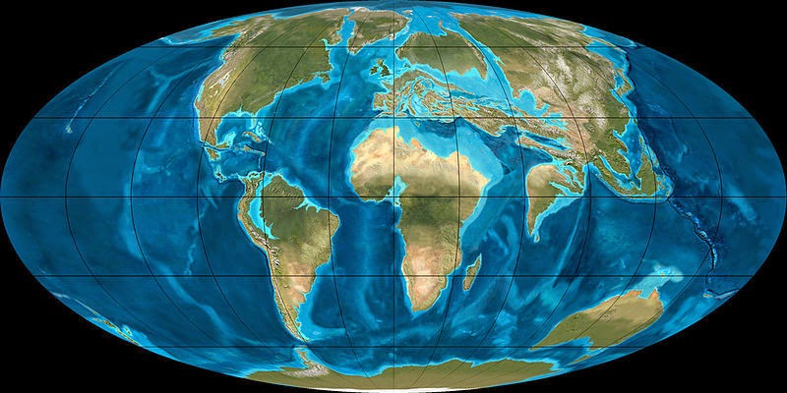
These are what the plates looked like at that time.
(image of plates - have to find)

The Pacific Plate was moving towards the Caribbean Plate, sliding under it, getting pushed into the hot, hot mantle, where it slowly melted.

(demonstrate with two sheets of chipboard)

As it melted, the heat and pressure built up under the Caribbean plate, until hot magma burst up through the crust. Now this was all taking place at the ocean’s floor, so what happened was underwater (or submarine) volcanoes. After millions of years of eruption after eruption, some of these volcanoes became so tall, they poked above the ocean’s surface, and formed islands.

This took about 5 million years to happen.

Then, while more volcanoes were forming, the two plates were also pushing against each other, forming underwater mountains that eventually poked above the surface of the ocean, also.
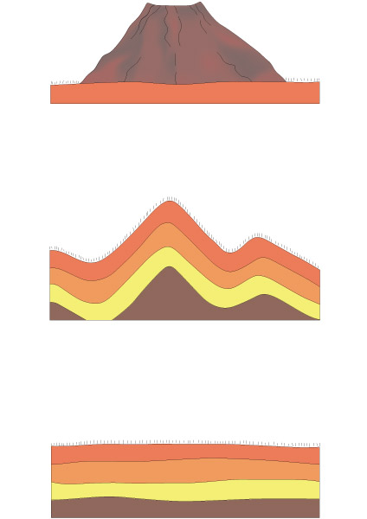
(demonstrate possibilities with layers of felt)

(chard U4 can also be used as a reference)

Remember how water can cut and carve through rock? And how ocean waves can slowly break down and wash away land? (reference to ocean waves erosion lesson/demonstration) This is what happened along the coasts of North America and South America. The Atlantic Ocean’s waves slowly, slowly, over several million years, picked up bits of rock, soil, sand, and mud, and carried them towards the newly formed islands, filling in the spaces between them.

Over time, the weight of the ocean pressed down on this sediment, pressing so hard that it became solid, hard rock.

And that is how the isthmus of Panama was formed.

Another day, we’ll talk more about how this tiny, tiny strip of land caused changes all around the world.

Possible Follow Up Work:
more detailed layers of the earth, timeline of plate tectonics, topography of ocean floor, volcanoes, submarine volcanoes, mountains, submarine mountain ranges

Story 2: The Separation of the Oceans, Part 1

Materials:
image of continents and oceans before Panama,
image of continents and oceans after Panama,
chart 10 (or other image showing current ocean currents)

Connecting Lessons:
Ocean Currents

Story:
Remember when we discussed how the isthmus of Panama was formed, and how I mentioned that this tiny sliver of land changed the whole world? Today, I’m going to tell you about one of those changes.

Here we have a map of how the world looks today. We have our continents (with North America and South America connected), and we have our oceans.

Who can point to the Atlantic Ocean? See these red currents here? This one is nice and warm, heated by the sun at the equator (perpendicular rays review). See how it flows westward, until it gets turned around here, because of the isthmus? It can’t pass through, so it turns northward. Some of it stays and warms the Gulf of Mexico, and the rest of it continues north along the coast of North America, before spreading westward again, towards Europe.

Did you know that if we didn’t have the Gulf Stream, scientists estimate European winters would average 41 degrees colder? The Gulf Stream plays a huge role in the weather of Western Europe. About 11,00 years ago, the North Atlantic Drift changed, and stopped bringing north warm water from the Gulf Stream. As a result, within tens of years, Europe almost entered another ice age. During the last ice age, the average world temperature was only 12 colder than it is today. That little change in temperature was enough to keep snow on the ground year round in northern parts of the world, including where we live here, in Wisconsin. Scientists are keeping a close eye on these ocean currents, because of the effects they have on weather.

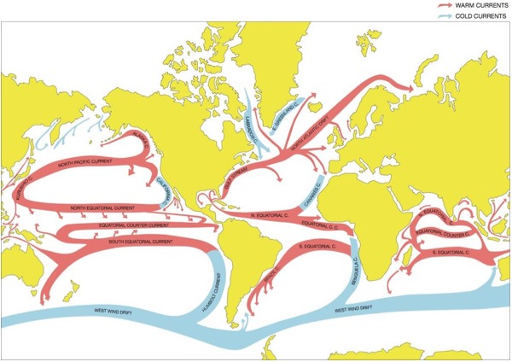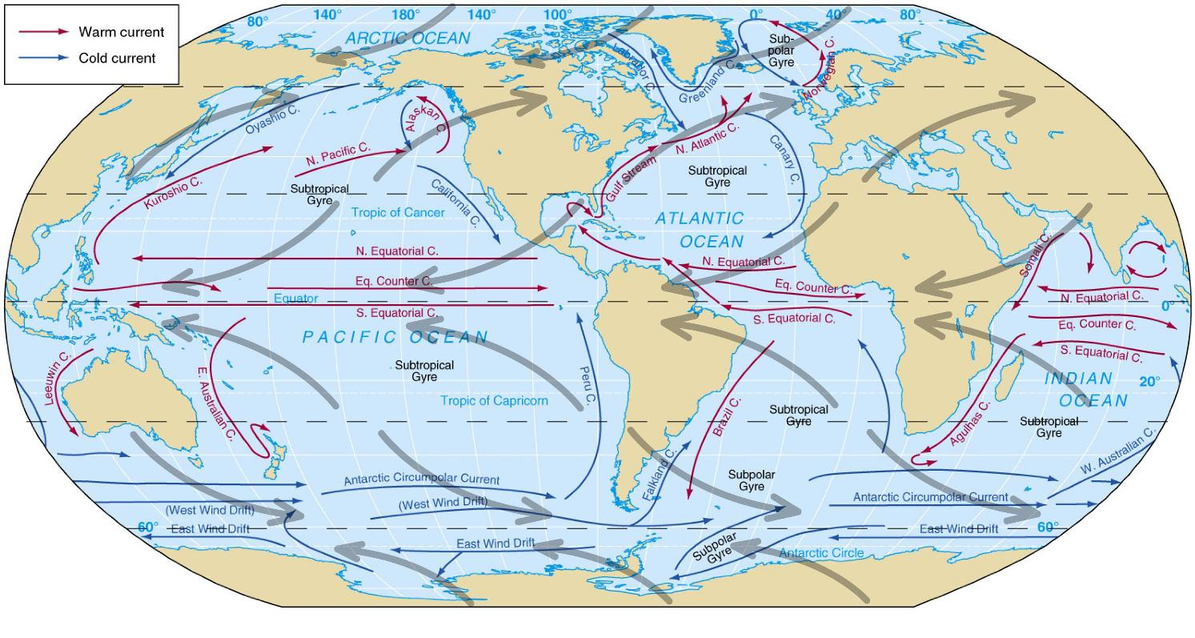
There was another important thing that happened when the oceans were separated. Not only did the Atlantic become warmer than the Pacific, but it became saltier. We’ll learn more about how that happened another day.

Possible Follow Up Work:
investigate Pacific Ocean currents that approach Central America;
ice ages;
northern hemisphere climate and weather patterns;
other ocean currents

Story 3 and Demo: The Separation of the Oceans, Part 2

Materials:
chart 27 (or map of world, showing biomes)
charts 3, 4, 5 (or images showing global wind patterns)
charts 7 and 8 (or images showing humid ocean air condensing into rain over land);
pan with water, salt, hot plate or other heat source, glass lid, hot pads, clean container

Connecting Lessons:
tropical rains
winds, spread of vegetation

Story:
Last time we met, we discussed how the separation of the Atlantic and Pacific Oceans changed the climate in Europe. Did you make any other discoveries you’d like to share?

Today, we’re going to look at something else that happened after the oceans were separated.

Let’s look at Africa. See how hot and dry this northern region is? (Sahara)

Winds move westward across this desert region, year-round. (have charts 3, 4, 5 available for looking at later)

The air in these winds gets very hot, because of that sub-tropical sun, and very, very thirsty, because there is no water for it to drink in the desert. It travels such a long way, with nothing at all to drink… until it reaches the Atlantic Ocean. The air is so thirsty that it drinks, drinks, drinks. It drinks all the way across the ocean, until it reaches land, here (point to isthmus). Then it cools down, starts to shiver and shrink, and lets go of its water, as rain.

These charts show the same thing. Hot air evaporates water from the oceans (chart 7), and drops the same water once it cools over land (chart 8).

But that’s not all. To tell you the rest of the story, we’ll have to do a little demonstration.
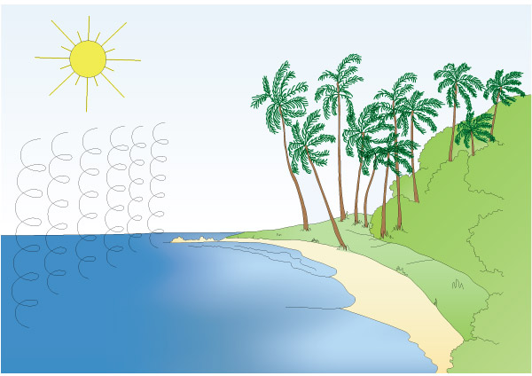
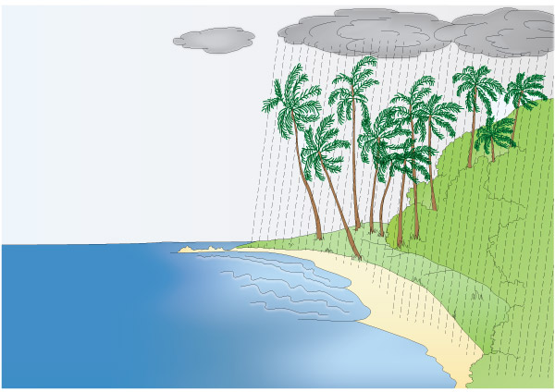
Demo:
Let’s pretend this is the Atlantic Ocean. (pot with clean water)

What can you tell me about ocean water? (it’s salty)

So we’re going to use this to help us. (salt)

Let’s mix together salt and water, to make our very own little ocean. Would anyone like to taste it? (taste)

Now, we’re going to add heat to our tropical ocean, just as the perpendicular rays of the sun heat the Atlantic Ocean near the equator. (turn on plate or other heat source)

And let’s add some atmosphere and gravity, to collect any clouds that may form. (glass lid)

When our cloud fills, we’ll move it over dry land, so it cools and drops water. (move steamy lid over clean container)

Here comes the rain. Would anyone like to taste it? (taste)

Does anyone notice a difference? (not salty)

Do you think the flavor of our mini Atlantic Ocean has changed? Why? (same amount of salt, same amount of water.

This is one of the reasons why the Atlantic Ocean is saltier than the Pacific. The salt gets left behind, and the oceans can no longer mix between the Americas. Saltier water is heavier, which makes cold currents fall even faster, speeding up some of the ocean currents we looked at last time. So salt can affect weather patterns, also.

Previously Received Demo (in Montessori lessons) - Cold Sinks, Heat Rises

Materials:
Clear baking dish, filled with room temperature water
Hot water, tinted red
Cold water, tinted blue

Procedure:
Carefully pour (or dropper) cold water into dish of water. Observe.
Carefully pour (or dropper) hot water into dish of water. Observe.

New demo (saltier water is heavier):

Materials:
water with salt and blue food coloring added
cold water with equal amount of salt and blue food coloring added
cold water with equal amount of blue food coloring added
three clear jars, each filled with room temperature water

Procedure:
Slowly pour (or dropper) salt water into room temperature water. Observe.
“I wonder what would happen if water was cold and salt?”
Repeat with cold saltwater. Observe.
“How quickly did the cold freshwater take to sink?”
Repeat with cold freshwater. Observe.

Repetition:
Children can time and chart how long it takes each of the three solutions to sink.

Possible Follow Up Work:
Following ocean currents across the globe (do the waters ever mix?);
Looking into details of global cold and warm water currents;
Mixing sea saltwater with proper water:salt proportions;
How the current salinity of the oceans remains stable;
Different ecosystems based on salinity and/or temperatures of the oceans;
Effects of ocean salinity, temperatures, and currents on extreme weather
Comparing weights of saltwater and freshwater
Also, does weight of saltwater = weight of water + salt?

Story 4: A Bridge Between the Americas

Materials:
outline map of North America, Central America, South America
atlas showing biomes, or chart 27 (spread of vegetation depending on rainfall)
images of racoon family animals
color pencils

Connecting lessons:
coming of life
timeline of life (shows eras, ice ages, key evolutionary moments)
biomes
animal story material or animal body functions material

Story:
So far, we’ve looked at how the isthmus of Panama had an effect on the oceans and weather patterns. Today, we’re going to start thinking about how it had an effect on living things.

When you think of North America, what animals do you think of? (answers may vary)

When you think of South America, what animals do you think of? (answers may vary)

Now, before the full isthmus of Panama formed, about 7.5 million years ago, the land in this area lifted enough to form shallow water pathways between the islands. Some mammals from North America were able to pass across, into South America.

Do any of these animals look familiar to you? (show images of kinkajou, olingo, olinguito, cacomistle)

How about this? (image of coati)

And this? (raccoon)

All of these animals are part of the raccoon family.

This one (raccoon) is native to North America.

This one (white-nosed coati) resides from southern North America through northern South America.

This one (ringtail) is native to North America as well, even though it closely resembles this one (cacomistles).

All of these (kinkajou, olingo, cacomistles) are native to Central and South America.

These are both native to South America (S.A. coati, olinguito). This one (olinguito) is found only is a small part of South America. It was “discovered” in 2013. Now that wasn’t the first time people had seen it. In fact, for more than 100 years, museums had this animal’s skull on display - they just had it labeled wrong! There was even one of these that traveled from zoo to zoo in the United States, during the 1960s and 70s, because the zoos thought it was one of these (olingos), but for some reason, it wasn’t breeding.

These different species of animal are spread throughout the Americas, some living in dry/arid habitats (ringtail), and others surviving in humid, tropical rainforests (olingo). But all of them are part of the raccoon family, which is native to North America. When those volcanic islands started to fill in the space between North and South America, and they became close enough, and the water between them shallow enough, some member or members of that ancient raccoon family made the journey south 7.5 million years ago, and over time, their bodies and behaviors changed to match their new environments, and gave birth to the new species we see today.

I wonder how exactly their bodies and behaviors adapted to math these environments. (indicate spread of vegetation/biomes)

Not only did animals move southward. Some animals migrated northward. Around 8 million years ago, giant ground sloths, the size of elephants, were one of those animals. They were one of several “island hoppers” - animals that crossed the volcanic islands before dirt and sand was washed in by the oceans to fill in those spaces between the islands and form the isthmus. Imagine how long their legs must have been to hop from island to island.

Other prehistoric animals crossed as well - the elephant family crossed southward from North America to South America. So did members of the dog, cat, and horse family. Members of the porcupine and armadillo family moved northward. And that’s not all that crossed. More families of mammals crossed both ways, sometimes clashing with each other, sometimes learning to live with one another… sometimes, either hunting or being hunted by each other.

Scientists call this migration the Great American Biotic Interchange. “Bio” is the Greek root word for “life.” Great American Biotic Interchange. Hmmm… I wonder if any other life forms moved across the continents?

Notes:
north: raccoon, ringtail
north and central - cacomistle
north to south - coatil
central and south - kinkajou, olingo,
south - olinguito, South American coati
Possible Follow Up Work:
How do geologists know the history of land formation?
Animal classification - family to genus to species
Evolution theories and concepts
Research and draw maps of other animal family distributions
Compare biomes/environments to animal adaptations; create maps, charts
Read about new evidence which shows animals may have crossed sooner - as early as 13-15 million years ago
Revisit timeline of life, or make a new one
Research the last ice age and the animals alive then
Animal migrations happening today
Did any plants spread between the Americas?

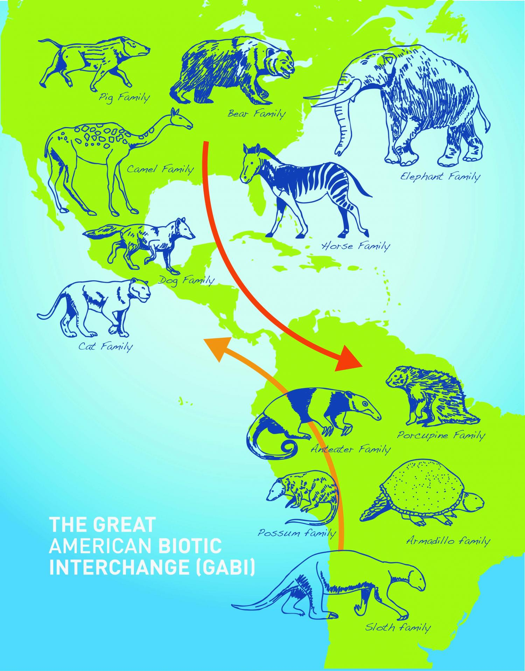

Story 5: Our Very Own Ancestors

Materials:
chart or map of oceans’ currents (conveyor belt)

Connecting Lessons:
Coming of Human Beings

Vocabulary:
Paleoclimatologist - someone who studies prehistoric evidence of climate change.

Story:
Today, I’m going to share with you one more change the formation of the Panamanian isthmus may have taken part in. I say may have, because when scientists make hypotheses, they’re making their best educated guesses, and then as time goes on, they and others continue to test and research these hypotheses, to see if they still believe them to be true or not. (Why do you think that is?)

So here is the hypotheses. Remember what we learned about the Gulf Stream bringing warm Atlantic ocean currents north to the European coastline, and how it keeps that part of the world about 40 warmer during winters? Well, there is a paleoclimatologist who believes the *** also made Africa colder and drier.

So here is the hypothesis currently being discussed by scientists:

But first, remember how I told you the Atlantic and Pacific don’t mix between the Americas? That is true. However, you may have noticed they do touch in other parts of the world.
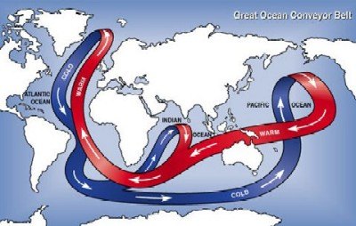
Let’s look at how that happens. (bring out chart or map)
The isthmus caused the Atlantic to become saltier, and heavier. (Remember?)
The warmth of the tropical sun warms the oceans’ surface water, here in the Pacific and Indian Ocean.
This warm water moves west around the Earth....
Until it gets turned north here, in the Atlantic Ocean, by the Panamanian isthmus.
It flows past Africa and Northern Europe, until finally, it is cooled by the Arctic Ocean.
The cold temperature plus the saltiness causes it to sink downwards.
It flows south again, then east, all the way until it reaches this part of the Pacific Ocean.
By this time, it has lost most of its saltiness, so it is lighter, and it it getting warmed by the sun again, so it rises back to the surface of the water.
And then, the cycle begins all over again.

Now, paleoclimatologists use evidence from millions of years ago to tell them what weather was like back then. They use clues. There is on paleoclimatologist who looked closely at cores, or cylinders, of earth drilled from deep in the African continent. When he looked at these cores, he was layers of rock that were different from each other. He was able to test them and see what they were made of, and then find out where they may have come from. This scientist found that during certain years (say, 23,000 years at a time), the rock showed that it blew in from another continent. Scientists guess this was a dry, hot time in Africa. The next layer may show that the rock was formed from dirt and minerals that were more local, or closer, and maybe they were wetter - showing that during that time, Africa was warmer and more humid. These cores show alternating bands, or layers, of cool dry rock and warmer, moister rock.

The interesting thing the paleoclimatologist found was that around 2.8 million years ago, soon after the isthmus of Panama was formed, the oceans separated, and the conveyor belt current began. He and others believe before the water became saltier and heavier, instead of sinking back into the Atlantic once it cooled down near the Arctic, it continued north into the Arctic, warming the waters there. But after the conveyor belt began, the warmer water stopped entering the Arctic, and the Arctic became colder and colder, until ice sheets formed on its surface. Sunlight bounced right off these ice sheets, making the Arctic Ocean even colder, as the sun was prevented from warming it.

The Arctic region became cold and frozen. An ice age began.

So what does this have to do with Africa, you may be wondering?

Let’s go back to the paleontologist. He found that around 2.8 million years ago, instead of each each rock layer being around 23,000 years deep, they became 40,000 years deep - almost double. This is big difference. This is tens of thousands of years. This is long enough for tropical forests to shrink, and their trees disappear, and forests to turn to grasslands, or maybe even deserts. It’s so long that any animals living there have to migrate to new areas, to live the way there were, or to slowly change, or evolve, into new bodies and new behaviors.

Once of those animals was Australopithecus. (show image)

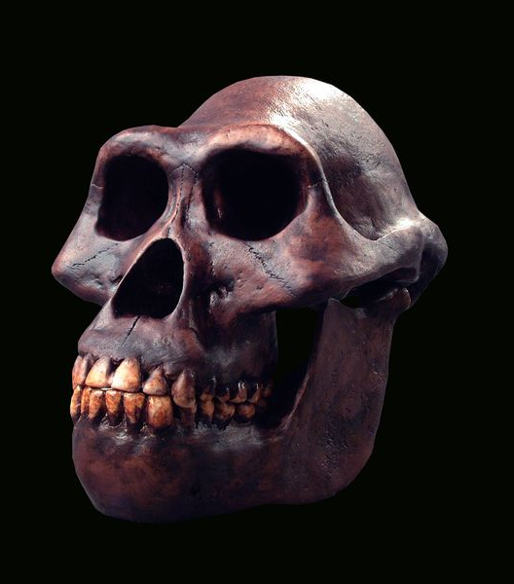
Smithsonian Magazine

And a little less than 3 million years ago, Australopithecus could no longer live part of its life in trees. It had to live its entire life on the ground. And so, Australopithecus branched into 2 distinct species: Paranthropus and Homo habilis. (photo of skulls)
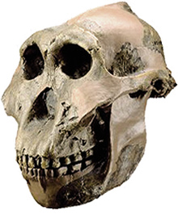Bradshaw foundation
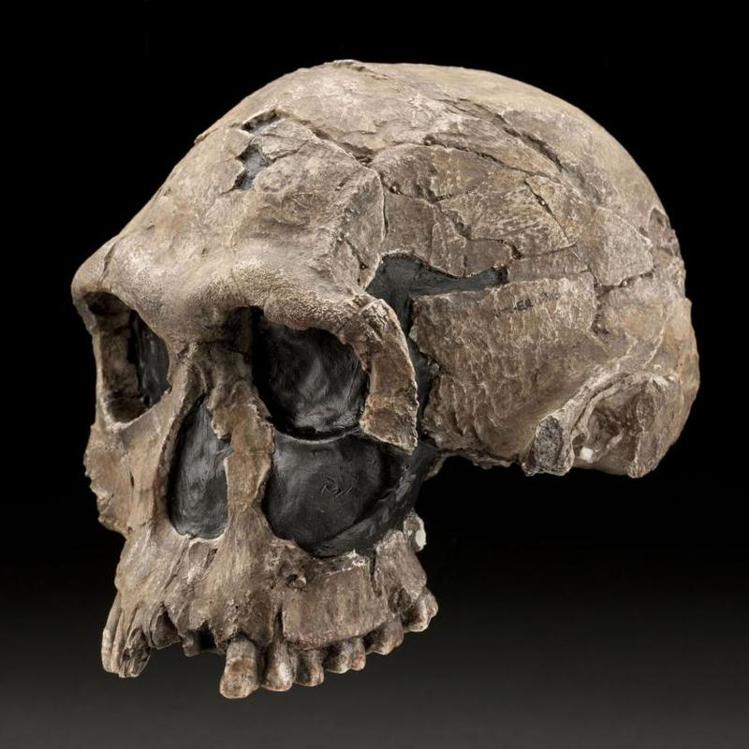
Smithsonian Museum of Natural History

One of them had a strong jaw for chewing. The other had a larger brain cavity in its skull.

1.7 million years ago, the core samples show another dry, colder period in Africa. At that same time, Homo erectus appeared.

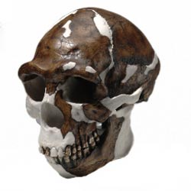
American Museum of Natural History

Do you notice the difference in the teeth? I wonder how different the rest of its body looked…

Then, 1 million years ago, the cold and dry period lasted not 40,000 years, but 100,000 years. Paranthropus died out, and Homo erectus survived.

Can you guess (or do you know) what Homo erectus evolved into, 200,000 years ago?

A series of stories….
X underwater volcanoes
X ocean currents
X hominid evolution
formation antarctic polar ice cap - Not done yet
X cooler northern european west coast climate
X animal migration
x (suggested as follow up) vegetation “migration”

References
earthobservatory.nasa.gov
livescience.com
weatheronline.co.uk
eduplace.com (Houghton-Mifflin)
eesc.columbia.edu
smithsonianmag.com
ncbi.nlm.nih.gov
animalfiles.com
nationalgeographic.com
armadillo-online.org
phys.org
sdnhm.org (San Diego Natural History Musem)
The Great American Biotic Interchange: Dispersals, Tectonics, Climate, Sea Level and Holding Pens - Woodburne, Michael O.
humanorigins.si.edu

THESE PAGES STILL UNDER CONSTRUCTION
Connections to Existing Lessons
* = included in Montessori lessons
** = terms/concepts not within Montessori lessons
Vocabulary / Concepts | Connecting Montessori Units / Lessons | DRAFT NOTES  Illustrative Charts
* isthmus | * land and water forms
* barysphere, lithosphere, hydrosphere, atmosphere, core, mantle, plastic mantle, crust, plates, basalt  ** biosphere, convergent boundary, subduction, submarine volcano, divergent boundary | * composition of the earth  * formation of mountains
** sedimentary | ** rock cycle
* equator, perpendicular rays, oblique rays, tropics, tropic of Capricorn, Tropic of Cancer, arctic, temperate, poles | * sun and earth  * zones | add more
* equatorial rain | * work of water | add more
* equatorial hot air | * work of air  * winds  * work chart for winds | add more  *** make new work chart for winds, without Panama (follow up)
*
** biome
* Cenozoic Era, Paleogene Period, Neogene Period, Miocene Epoch | * timeline of life  * coming of human beings | make / get maps of Earth during these times
paleoclimatology
geobiology
evolutionary ecology

Related Montessori Lessons:

geography
land and water forms
composition of the earth
sun and earth
work of water
work of air
people of different zones
biology
main parts of plants and their functions
animal body functions material
ecology
history
timeline of life (shows eras, ice ages, key evolutionary moments)
coming of human beings (humans appearing relatively late on earth)

Concepts and Vocabulary: ???????????????
geobiology
evolutionary ecology
ecology (biotic, abiotic, producers, consumers, decomposers, mutualism/symbiosis, diversification, adaptation) ****
plants (anatomical and behavioral terms)
animal vocabulary (anatomical and behavioral terms)
plate tectonics (sublimation, submarine volcanoes,

Materials:
Montessori (or comparable) lessons listed above
Montessori charts (ocean currents, wind currents, vegetation, interdependency, plants)
Montessori materials (botany and fungi nomenclature, animal body function materials, timeline of life)
Images of flora and fauna of Panama
Images of flora and fauna originally from North and South America
Weather reports and forecasts for Panama
Resources describing the salinity of Atlantic and Pacific Oceans
Resources (atlases) describing average and seasonal weather for the world
Resources (atlases) describing biomes of the world

NGSS Standards:
4 LS1.A: Structure and Function Plants and animals have both internal and external structures that serve various functions in growth, survival, behavior, and reproduction.
4 LS1.D: Information Processing Different sense receptors are specialized for particular kinds of information, which may be then processed by the animal’s brain. Animals are able to use their perceptions and memories to guide their actions.
4 ESS1.C: The History of Planet Earth Local, regional, and global patterns of rock formations reveal changes over time due to earth forces, such as earthquakes. The presence and location of certain fossil types indicate the order in which rock layers were formed.
4 ESS2.A: Earth Materials and Systems Rainfall helps to shape the land and affects the types of living things found in a region. Water, ice, wind, living organisms, and gravity break rocks, soils, and sediments into smaller particles and move them around.
4 ESS2.B: Plate Tectonics and Large-Scale System Interactions The locations of mountain ranges, deep ocean trenches, ocean floor structures, earthquakes, and volcanoes occur in patterns. Most earthquakes and volcanoes occur in bands that are often along the boundaries between continents and oceans. Major mountain chains form inside continents or near their edges. Maps can help locate the different land and water features areas of Earth.
4 ESS2.E: Biogeology Living things affect the physical characteristics of their regions.
5 PS3.D: Energy in Chemical Processes and Everyday Life The energy released [from] food was once energy from the sun that was captured by plants in the chemical process that forms plant matter (from air and water).
5 LS1.C: Organization for Matter and Energy Flow in Organisms Food provides animals with the materials they need for body repair and growth and the energy they need to maintain body warmth and for motion.
5 LS1.C: Organization for Matter and Energy Flow in Organisms Plants acquire their material for growth chiefly from air and water.
5 LS2.A: Interdependent Relationships in Ecosystems The food of almost any kind of animal can be traced back to plants. Organisms are related in food webs in which some animals eat plants for food and other animals eat the animals that eat plants. Some organisms, such as fungi and bacteria, break down dead organisms (both plants or plants parts and animals) and therefore operate as “decomposers.” Decomposition eventually restores (recycles) some materials back to the soil. Organisms can survive only in environments in which their particular needs are met. A healthy ecosystem is one in which multiple species of different types are each able to meet their needs in a relatively stable web of life. Newly introduced species can damage the balance of an ecosystem.
5 LS2.B: Cycles of Matter and Energy Transfer in Ecosystems Matter cycles between the air and soil and among plants, animals, and microbes as these organisms live and die. Organisms obtain gases, and water, from the environment, and release waste matter (gas, liquid, or solid) back into the environment.
5 ESS2.A: Earth Materials and Systems Earth’s major systems are the geosphere (solid and molten rock, soil, and sediments), the hydrosphere (water and ice), the atmosphere (air), and the biosphere (living things, including humans). These systems interact in multiple ways to affect Earth’s surface materials and processes. The ocean supports a variety of ecosystems and organisms, shapes landforms, and influences climate. Winds and clouds in the atmosphere interact with the landforms to determine patterns of weather.
5 ESS2.C: The Roles of Water in Earth’s Surface Processes Nearly all of Earth’s available water is in the ocean. Most freshwater is in glaciers or underground; only a tiny fraction is in streams, lakes, wetlands, and the atmosphere.
MS LS1.B: Growth and Development of Organisms
▪ Animals engage in characteristic behaviors that increase the odds of reproduction.
▪ Plants reproduce in a variety of ways, sometimes depending on animal behavior and specialized features for reproduction.
▪ Genetic factors as well as local conditions affect the growth of the adult plant.
MS LS1.C: Organization for Matter and Energy Flow in Organisms
▪ Plants, algae (including phytoplankton), and many microorganisms use the energy from light to make sugars (food) from carbon dioxide from the atmosphere and water through the process of photosynthesis, which also releases oxygen. These sugars can be used immediately or stored for growth or later use.
MS PS3.D: Energy in Chemical Processes and Everyday Life
▪ The chemical reaction by which plants produce complex food molecules (sugars) requires an energy input (i.e., from sunlight) to occur. In this reaction, carbon dioxide and water combine to form carbon-based organic molecules and release oxygen.
▪ Cellular respiration in plants and animals involve chemical reactions with oxygen that release stored energy. In these processes, complex molecules containing carbon react with oxygen to produce carbon dioxide and other materials.
MS LS2.A: Interdependent Relationships in Ecosystems
▪ Organisms, and populations of organisms, are dependent on their environmental interactions both with other living things and with nonliving factors.
▪ In any ecosystem, organisms and populations with similar requirements for food, water, oxygen, or other resources may compete with each other for limited resources, access to which consequently constrains their growth and reproduction.
▪ Growth of organisms and population increases are limited by access to resources.
▪ Similarly, predatory interactions may reduce the number of organisms or eliminate whole populations of organisms. Mutually beneficial interactions, in contrast, may become so interdependent that each organism requires the other for survival. Although the species involved in these competitive, predatory, and mutually beneficial interactions vary across ecosystems, the patterns of interactions of organisms with their environments, both living and nonliving, are shared.
MS LS2.B: Cycle of Matter and Energy Transfer in Ecosystems
▪ Food webs are models that demonstrate how matter and energy is transferred between producers, consumers, and decomposers as the three groups interact within an ecosystem. Transfers of matter into and out of the physical environment occur at every level. Decomposers recycle nutrients from dead plant or animal matter back to the soil in terrestrial environments or to the water in aquatic environments. The atoms that make up the organisms in an ecosystem are cycled repeatedly between the living and nonliving parts of the ecosystem.
MS LS2.C: Ecosystem Dynamics, Functioning, and Resilience
▪ Ecosystems are dynamic in nature; their characteristics can vary over time. Disruptions to any physical or biological component of an ecosystem can lead to shifts in all its populations.
▪ Biodiversity describes the variety of species found in Earth’s terrestrial and oceanic ecosystems. The completeness or integrity of an ecosystem’s biodiversity is often used as a measure of its health.
MS LS4.A: Evidence of Common Ancestry and Diversity
▪ The collection of fossils and their placement in chronological order (e.g., through the location of the sedimentary layers in which they are found or through radioactive dating) is known as the fossil record. It documents the existence, diversity, extinction, and change of many life forms throughout the history of life on Earth.
▪ Anatomical similarities and differences between various organisms living today and between them and organisms in the fossil record, enable the reconstruction of evolutionary history and the inference of lines of evolutionary descent.
▪ Comparison of the embryological development of different species also reveals similarities that show relationships not evident in the fully-formed anatomy.
MS LS4.B: Natural Selection
▪ Natural selection leads to the predominance of certain traits in a population, and the suppression of others.
▪ In artificial selection, humans have the capacity to influence certain characteristics of organisms by selective breeding. One can choose desired parental traits determined by genes, which are then passed onto offspring.
MS LS4.C: Adaptation
▪ Adaptation by natural selection acting over generations is one important process by which species change over time in response to changes in environmental conditions. Traits that support successful survival and reproduction in the new environment become more common; those that do not become less common. Thus, the distribution of traits in a population changes.
MS ESS1.C: The History of Planet Earth ▪ Tectonic processes continually generate new ocean sea floor at ridges and destroy old sea floor at trenches.
MS ESS2.A: Earth’s Materials and Systems
▪ All Earth processes are the result of energy flowing and matter cycling within and among the planet’s systems. This energy is derived from the sun and Earth’s hot interior. The energy that flows and matter that cycles produce chemical and physical changes in Earth’s materials and living organisms.
▪ The planet’s systems interact over scales that range from microscopic to global in size, and they operate over fractions of a second to billions of years. These interactions have shaped Earth’s history and will determine its future.
MS ESS2.B: Plate Tectonics and Large-Scale System Interactions
▪ Maps of ancient land and water patterns, based on investigations of rocks and fossils, make clear how Earth’s plates have moved great distances, collided, and spread apart.
MS ESS2.C: The Roles of Water in Earth’s Surface Processes
▪ Water continually cycles among land, ocean, and atmosphere via transpiration, evaporation, condensation and crystallization, and precipitation, as well as downhill flows on land.
▪ The complex patterns of the changes and the movement of water in the atmosphere, determined by winds, landforms, and ocean temperatures and currents, are major determinants of local weather patterns.
▪ Global movements of water and its changes in form are propelled by sunlight and gravity.
▪ Variations in density due to variations in temperature and salinity drive a global pattern of interconnected ocean currents.
▪ Water’s movements—both on the land and underground—cause weathering and erosion, which change the land’s surface features and create underground formations.
MS ESS2.D: Weather and Climate
▪ Weather and climate are influenced by interactions involving sunlight, the ocean, the atmosphere, ice, landforms, and living things. These interactions vary with latitude, altitude, and local and regional geography, all of which can affect oceanic and atmospheric flow patterns.
▪ Because these patterns are so complex, weather can only be predicted probabilistically.
▪ The ocean exerts a major influence on weather and climate by absorbing energy from the sun, releasing it over time, and globally redistributing it through ocean currents.

Cross-cutting Concepts:

Grades 4-5

Systems and System Models A system can be described in terms of its components and their interactions.

Patterns Patterns can be used as evidence to support an explanation.

Scientific Knowledge Assumes an Order and Consistency in Natural Systems Science assumes consistent patterns in natural systems.

Energy and Matter Energy can be transferred in various ways and between objects.
Energy and Matter Matter is transported into, out of, and within systems.

Middle School

Systems and System Models
Systems may interact with other systems; they may have sub-systems and be a part of larger complex systems.

Energy and Matter
Within a natural system, the transfer of energy drives the motion and/or cycling of matter.

Structure and Function
Complex and microscopic structures and systems can be visualized, modeled, and used to describe how their function depends on the relationships among its parts, therefore complex natural structures/systems can be analyzed to determine how they function.

