Name: _________________________________________ Date: __________________________ Teacher_________________________
VISIT TO THE FOREST: BARRO COLORADO VIRTUAL TOUR/WISCONSIN FORESTS ACTIVITY FIELD TRIP
TOPIC: ________________________________________
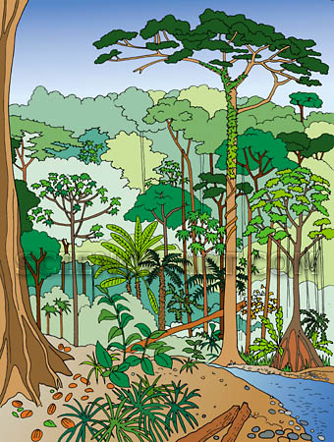

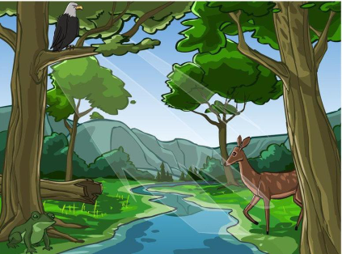

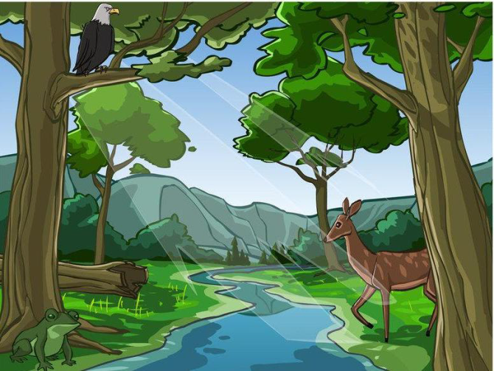
VISIT TO THE FOREST: FIELD OBSERVATION GUIDE SHEET
Name: ___________________________ Date: _____________ Teacher: ______________________

Location: ____________________________ Date: __________________
Time: ____________________ Temperature: ___________________
Name of specimen:_____________________________________________________
Description: _________________________________________________
Where found (habitat or microhabitat): __________________________
__________________________________________________________
__________________________________________________________
What might it eat? __________________________________________
__________________________________________________________
Other observations: _________________________________________
__________________________________________________________

Location: ____________________________ Date: __________________
Time: ____________________ Temperature: ___________________
Name of specimen:_____________________________________________________
Description: _________________________________________________
Where found (habitat or microhabitat): __________________________
__________________________________________________________
__________________________________________________________
What might it eat? __________________________________________
__________________________________________________________
Other observations: _________________________________________
__________________________________________________________

Picture
Picture

