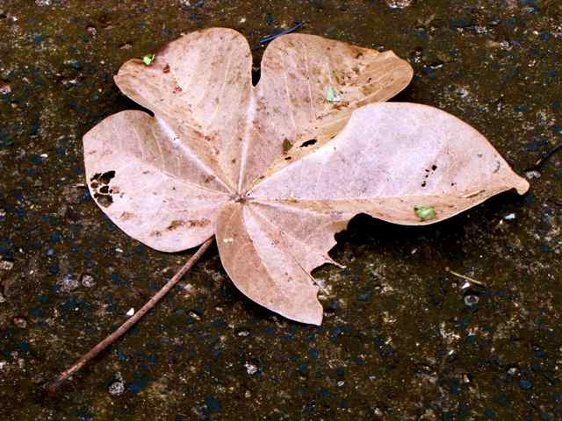

Curricular Goals

In this introductory study of ecology, students will learn about the ecology and climate of Barro Colorado Island (BCI), Panama and the ecology and climate of Milwaukee, Wisconsin. Within this context students will review how ecosystem and climate are determined, examine the importance of healthy ecosystems, study how organisms meet their basic survival needs, consider how organisms have evolved, demonstrate ecosystem interactions, analyze the relationship between omnivores and herbivores and justify the importance of forest conservation.

Students will also engage in learning about how humans understand and explain the natural world through an interactive web-based resource that was built with interviews of scientists and students working on BCI during the summer of 2010. They will realize their ability to pose questions and conduct research, in the same way scientists do on BCI, by participating in a performance task that assesses student understanding of climate and species diversity in partnership with the Urban Ecology Center (UEC).

Students will develop and apply inquiry-based research to make comparisons between Milwaukee and BCI. In a culminating performance task, students will present their understanding of the similarities and differences of the climate and biodiversity of BCI and Milwaukee. Students and teachers will work with Urban Ecology Center (in Milwaukee, WI) staff to census the flora and fauna of Riverside Park and compare that data to what they have learned and what is published about BCI. The product will clearly display similarities and differences between a temperate climate, flora and fauna, and a tropical climate, flora and fauna. Each student will also have the opportunity to conduct a student driven inquiry project that may be inspired by the work they have done in the unit or scientists they have learned about from BCI. The unit concludes with students persuading their peers of the importance of habitat conservation.

Panamá T.R.E.E.E.S.

5b Global Climate Change

Assessment Task Blueprint (for teacher use only)

Understandings or goals will be assessed through this task:

Criteria are implied in the standards and understandings, regardless of the task specifics. Qualities student work must demonstrate to signify that standards were met.

Authentic performance task for students to demonstrate understanding: (task overview)

Student products and performances to provide evidence of desired understandings:

Criteria by which student products and performances be evaluated:

Where and why

Hook and hold

Equip

Rethink and reflect

Evaluate

Tailored

Organized

Unit

Learning Activities

|  |  |  |
| --- | --- | --- |
| Lesson  number | WHERE  TO | activity, learning objective |
|  |  |  |
|  |  |  |
|  |  |  |
|  |  |  |
|  |  |  |

|  |  |  |
| --- | --- | --- |
|  |  |  |
|  |  |  |
|  |  |  |
|  |  |  |
|  |  |  |
| key vocabulary |  |  |
| print resources |  |  |
| online resources |  |  |