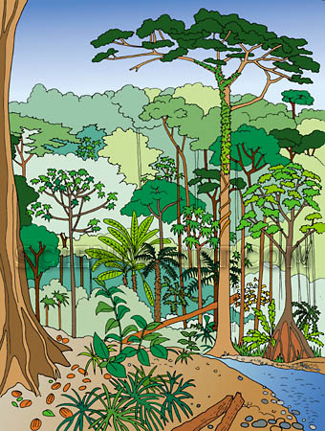
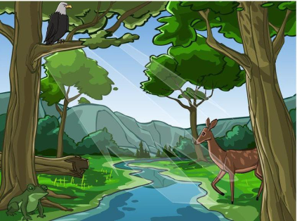
Classroom Lab Report
Name: ________________________________
Date: ____________________ Points _______
Teacher:

Scientific Protocol | Description | Illustrations
Problem

Hypothesis

Experiment

Observations

Conclusions

Materials
(Include Bibliography)

Rubric adapted from rubistar.4teachers.org

